**S. M. B. TORGALKAR JR. COLLEGE, RATNAGIRI WEBSITE**

**A Project Report**

Submitted in partial fulfilment of the

Requirements for the award of the Degree of

**BACHELOR OF SCIENCE (INFORMATION TECHNOLOGY)**

**By**

Mr.Sahil Shailesh Amberkar

Seat Number – TT240002

**Under the esteemed guidance of**

**Mr. S. D.Joshi**

**Assistant Professor of Information Technology Department at**

**R. P. Gogate College of Arts & Science and R. V. Jogalekar College of Commerce (AUTONOMOUS), Ratnagiri.**



**DEPARTMENT OF INFORMATION TECHNOLOGY**

**R. P. Gogate College of Arts & Science and R. V. Jogalekar College of Commerce (AUTONOMOUS), Ratnagiri.**

**415612**

**MAHARASHTRA**

**2023-24**

**PROJECT PROPOSAL**

PRN No. : 2021016400646304 Roll No: TTA11

1. Name of the Student : Sahil Shailesh Amberkar
2. Title of the Project : S. M. B. Torgalkar Jr. College, Ratnagiri Website
3. Name of the Guide : Mr. S. D. Joshi
4. Teaching experience of : 02 years
5. Is this your first submission? : Yes / No

Signature of the Student Signature of the Guide

Date: Date:

Signature of the Coordinator /HOD

Date:

**R. P. Gogate College of Arts & Science and R. V. Jogalekar College of Commerce (AUTONOMOUS), Ratnagiri.**

**RATNAGIRI-MAHARASHTRA-415612**

**DEPARTMENT OF INFORMATION TECHNOLOGY**



**CERTIFICATE**

This is to certify that the project entitled, **"S. M. B. Torgalkar Jr. College, Ratnagiri Website** **"**, is bona fide work of **Mr.Sahil Shailesh Amberkar** bearing Seat. No: (TT240002) submitted in partial fulfilment of the requirements for the award of degree of BACHELOR OF SCIENCE in INFORMATION TECHNOLOGY from R. P. Gogate College of Arts & Science and R. V. Jogalekar College of Commerce (AUTONOMOUS), Ratnagiri.

**Internal Guide Coordinator/HOD**

**External Examiner**

**Date: College Seal**

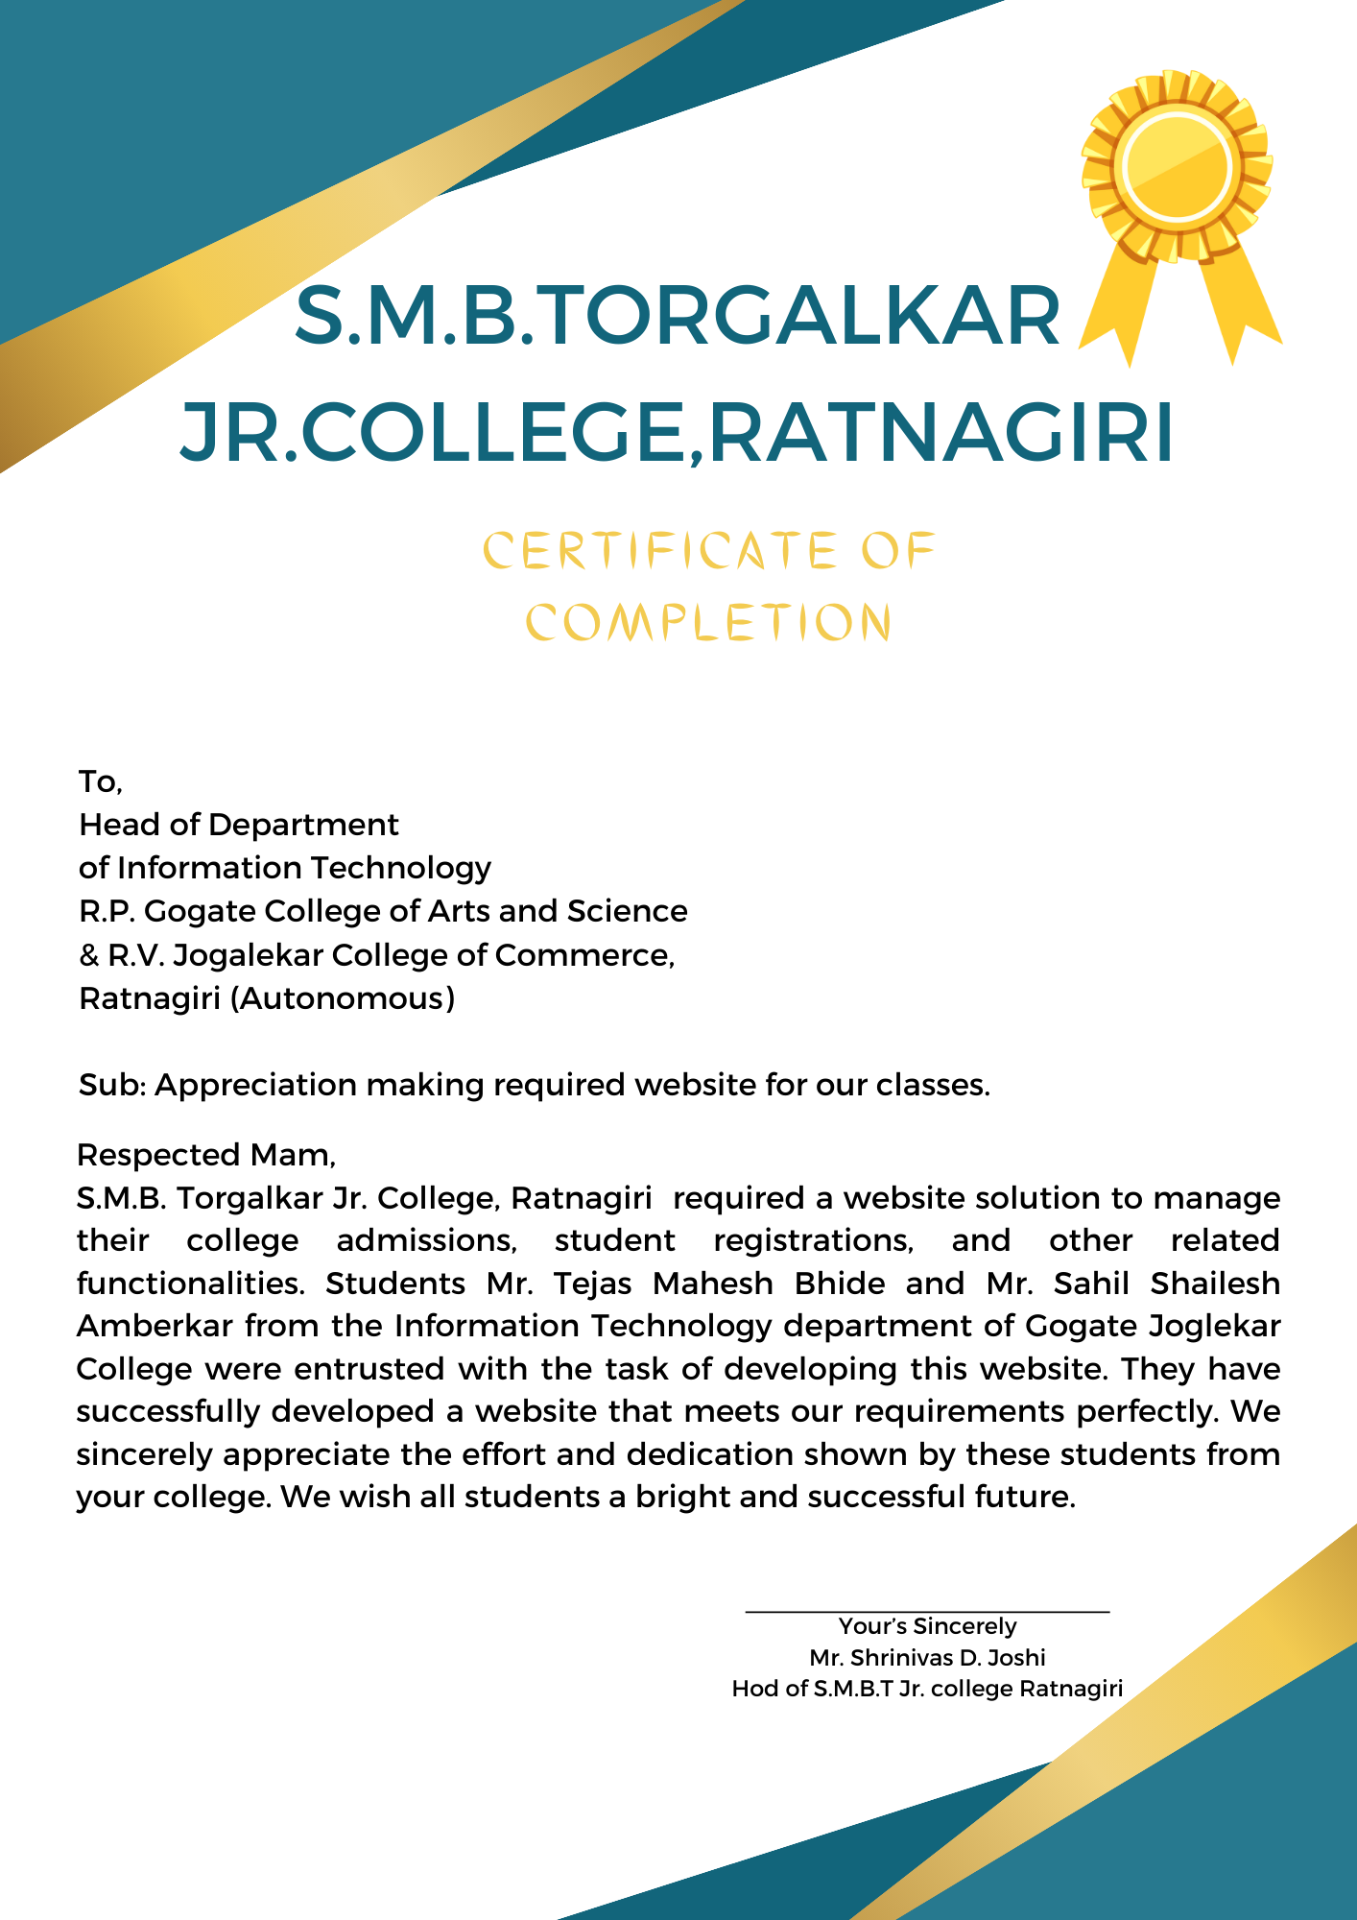

# ABSTRACT

The “**S. M. B. Torgalkar Jr. College, Ratnagiri Website”** project aims to develop a comprehensive online platform for S. M. B. Torgalkar Jr. College, providing students, faculty, and stakeholders with easy access to information, resources, and services. The S. M. B. Torgalkar Jr. College Website offers a user-friendly interface with intuitive navigation, enabling visitors to explore various sections and access relevant information effortlessly. The website provides detailed insights into the college's history, vision, and mission, highlighting its commitment to academic excellence and holistic development of students.

The website incorporates essential features and functionalities, including:

1. Academic Programs: The website showcases a wide range of undergraduate and postgraduate programs offered by S. M. B. Torgalkar Jr. College.
2. Admissions: The admissions section provides comprehensive details about the admission process, application requirements, and important dates.
3. Faculty and Staff: This section features profiles of the college's esteemed faculty and staff members.
4. Facilities and Infrastructure: The website highlights the state-of-the-art facilities and infrastructure available at S. M. B. Torgalkar Jr. College.
5. Events and Activities: Students and faculty can stay updated on upcoming events and actively participate in the vibrant college community.
6. Student Resources: The website provides a wealth of resources to support students' academic journey, including course materials, study guides, examination schedules, and online learning platforms.
7. Contact and Feedback: The website offers multiple channels for communication, allowing visitors to get in touch with the college administration, faculty, and staff. Feedback forms and contact information facilitate seamless communication, ensuring prompt resolution of queries and concerns.

Overall, the S. M. B. Torgalkar Jr. College Website project aims to enhance communication, collaboration, and accessibility within the college community.

# ACKNOWLEDGEMENT

I would like to express my sincere gratitude to several individuals for supporting me throughout the project.

I am grateful to **Dr. M. R. Sakhalkar**, Principal and **Dr. A. M. Kulkarni** Vice Principal (Science Faculty) Coordinator **Dr. V. V. Bhide** of R. P. Gogate College of Arts & Science and R. V. Jogalekar College of Commerce (AUTONOMOUS), Ratnagiri for providing all the necessary facilities of laboratory and library at R. P. Gogate College of Arts & Science and R. V. Jogalekar College of Commerce (AUTONOMOUS), Ratnagiri.

I wish to express my sincere thanks to **Mrs. M. A. Sahasrabuddhe**, Head of the Department of Information Technology for giving me the opportunity to complete the project work by providing valuable guidance to complete the task.

I would also like to express my sincere thanks to our **Respected Teachers** for helping and guiding me throughout the finalization of project.

I would like to thanks my guide **Mr. S. D. Joshi,** for his guidance, enthusiasm, patience, helpful information and practical advice that has helped me a lot in completion of my project.

Last but not the least my special thanks to my parents, my friends and all those people who have encouraged me, helped me to complete this project successfully in time.

# DECLARATION

I hereby declare that the project entitled, “**S. M. B. Torgalkar Jr. College, Ratnagiri Website**” done at **R. P.** **Gogate College of Arts & Science and R. V. Jogalekar College of Commerce (AUTONOMOUS), Ratnagiri**, has not been in any case duplicated to submit to any other university for the award of any degree. To the best of my knowledge other than me, no one has submitted to any other university.

The project is done in partial fulfilment of the requirements for the award of degree of

BACHELOR OF SCIENCE (INFORMATION TECHNOLOGY) to be submitted as final semester project as part of our curriculum.

Mr. Sahil Shailesh Amberkar

**INDEX**

|  |  |  |
| --- | --- | --- |
| **Sr. No.** | **Content** | **Page No.** |
| **1** | **Introduction** | 1-3 |
| 1.1 Background | 1 |
| 1.2 Objectives | 1 |
| 1.3 Scope, Purpose, Applicability | 2 |
| 1.3.1 Scope | 2 |
| 1.3.2 Purpose | 2 |
| 1.3.3 Applicability | 3 |
| **2** | **System Analysis** | 4-7 |
| 2.1 Existing System | 4 |
| 2.2 Proposed System | 4 |
| 2.2.1 Advantages | 4 |
| 2.3 Problem Definition | 5 |
| 2.4 Requirement Specification | 5 |
| 2.5 Planning and Scheduling - Gantt Chart | 6 |
| 2.6 Hardware and Software Requirements | 7 |
| **3** | **System Design** | 8-19 |
| 3.1 Module Division | 8 |
| 3.2 Data Design (Database Table) | 9 |
| 3.2.1 Data Dictionary | 9 |
| 3.2.2 Schema Design | 9 |
| 3.3 UML Diagrams | 12 |
|  | 3.4 Event Table | 19 |
| 4 | **Implementation and Testing** | 20-30 |
|  | 4.1 Connection Code | 20 |
|  | 4.2 Test Case Table | 30 |
| **5** | **User Interface Design** | 32-37 |
| **6** | **Conclusion** | 38 |
| **7** | **References** | 39 |

**LIST OF DIAGRAMS**

|  |  |  |
| --- | --- | --- |
| **Sr. No.** | **Diagram Name** | **Page No.** |
| 1 | Entity Relationship Diagram | 12 |
| 2 | Use case Diagram | 12-15 |
| 3 | Class Diagram | 16 |
| 4 | Sequence Diagram | 17 |
| 5 | Deployment Diagram | 18 |

# 1. Introduction

**1.1 Background**

The S. M. B. Torgalkar Jr. College Website project was created to make things easier for the college and the people who study and work there. It's like a new and improved website for the college. The goal is to give students, teachers, and others a website that's easy to use and has lots of helpful information. You can find out about the different classes you can take, how to apply to the college, learn about the teachers, see the college's cool buildings, find out about events, get study materials, and talk to the college if you have questions or suggestions. The website is all about making things better and keeping everyone connected at the college.

## 1.2 Objectives

The S. M. B. Torgalkar Jr. College Website has several key objectives to benefit students, faculty, and stakeholders. First and foremost, it aims to simplify the process of finding important information. This includes details about the college's academic programs and how to apply for them. Additionally, the website seeks to showcase the college's strengths by highlighting its faculty members and state-of-the-art facilities. Keeping everyone in the loop is another priority, with the website providing updates on upcoming events and activities to foster a sense of community and engagement. Furthermore, it aims to support students in their academic journey by offering study materials and resources. Lastly, the website aims to promote open communication by providing channels for questions, feedback, and suggestions, ensuring that the college community stays connected and can easily reach out for assistance. In summary, the S. M. B. Torgalkar Jr. College Website project is all about making college life more accessible, engaging, and informative for everyone involved.

## 1.3 Scope, Purpose, Applicability

### 1.3.1 Scope

The scope of the S. M. B. Torgalkar Jr. College Website encompasses a wide range of features and functionalities tailored to meet the needs of its diverse user base:

1. Academic Programs: The website will provide detailed information about undergraduate and postgraduate programs offered by the college, ensuring prospective students can make informed decisions about their education.

2. Admissions: It will cover admission processes, requirements, and important dates, simplifying the application process for prospective students.

3. Faculty and Staff: Faculty and staff profiles will be featured to promote transparency and trust within the college community.

4. Facilities and Infrastructure: The website will showcase the college's state-of-the-art facilities and infrastructure, highlighting its commitment to providing a conducive learning environment.

5. Events and Activities: Upcoming events and activities will be regularly updated to encourage active participation and a vibrant college community.

6. Student Resources: A wealth of resources, including study materials and online learning platforms, will be made available to support students in their academic endeavours.

7. Contact and Feedback: Multiple communication channels and feedback forms will ensure easy access to college administration, faculty, and staff for queries and concerns, promoting open communication.

### 1.3.2 Purpose

The primary purpose of the S. M. B. Torgalkar Jr. College Website is to serve as a comprehensive and user-friendly online platform for the college community, including students, faculty, and stakeholders. It aims to fulfil several key objectives:

1. Information Dissemination: To provide easy access to essential information about academic programs, admission processes, faculty profiles, facilities, events, and resources.

1. Enhanced Communication: To facilitate seamless communication and collaboration among students, faculty, staff, and administration through multiple channels, including contact forms and feedback mechanisms.
2. Engagement and Community Building: To promote a sense of belonging and active participation within the college community by keeping everyone informed about upcoming events and activities.

4. Academic Support: To support students' academic journeys by offering valuable resources such as course materials, study guides, and examination schedules.

5. Showcasing Excellence: To showcase the college's commitment to academic excellence and holistic development by highlighting its achievements, vision, and mission.

### 1.3.3 Applicability

The S. M. B. Torgalkar Jr. College Website is applicable to a wide range of individuals and groups. Prospective students can use it to explore academic programs and admission details, while current students benefit from resources and event updates. Faculty and staff can showcase profiles and engage with colleagues, and parents can stay informed about their children's education. The college administration can efficiently communicate and gather feedback, while alumni can stay connected and access specific resources. External stakeholders and the general public can learn about the college's mission and achievements. In summary, the website serves as a vital information and communication hub for the entire college community, including students, faculty, staff, parents, alumni, and external stakeholders.

# 2. System Design

## 2.1 Existing System

Early days **S. M. B. Torgalkar Jr. College** perform student admission process manually. It required lot of time to record or to retrieve the details. The employees who have to record the details must perform their job very carefully. Even a small mistake would create a lot of problems. Security of information is very less. Report generations of all the information is very tough task.

Maintenance of student’s information is a very complex task. In addition to its maintenance of student’s documents manually is a complex task.

All the operations must be performed in perfect manner for the maintenance of the library without any degradation which may finally result in the failure of the entire system.

## Limitations:

* Data getting mixed.
* Difficult to manage details of the student.
* More manual work required.

## 2.2 Proposed System:-

The current system will be user-friendly i.e. easy to use. It will reduce the inconveniences that is found in the existing system.

### 2.2.1 Advantages:-

* Saves time and efforts.
* Accessible from anywhere and anytime.
* Easy Admission management with detailed information.
* No risk of data getting mixed

## 2.3 Problem Definition:-

The problem definition for the S. M. B. Torgalkar Jr. College Website project revolves around the need to enhance communication, accessibility, and engagement within the college community. The existing system may lack a centralized and user-friendly platform for students, faculty, and stakeholders to access crucial information, academic resources, and services. Additionally, the admissions process might not be as transparent as desired, hindering prospective students' ability to navigate the application process effectively. Insufficient online resources and limited opportunities for interaction could also be limiting the overall educational experience. Therefore, the project aims to address these issues by creating a comprehensive online platform that fosters transparent admissions, facilitates seamless communication, and enriches the academic journey of students and the collaborative experience of faculty and staff.

## 2.4 Requirement Specification:-

The website is expected to be:-

* User friendly
* Admission data management.
* Faster, flexible and convenient.

## 2.5 Planning and Scheduling – Gantt chart

* **Development:**

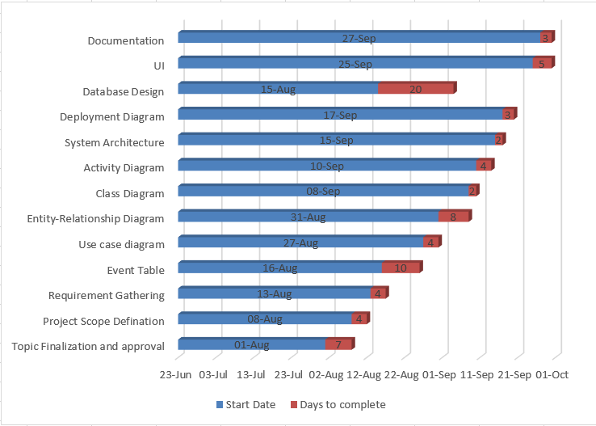

* **Implementation:**

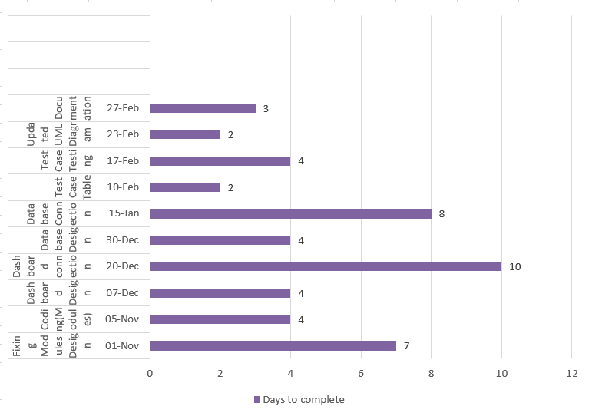

## 2.6 Software and Hardware Requirements:

##  Hardware Requirements:

* Processor:- minimum Intel(R) Core(TM) i3-6100U
* Speed:-2.30 GHZ
* Hard Disk capacity:-1TB
* Memory capacity:-minimum 2 GB and above

##  Software Requirements:-

* Browser: Google Chrome, Firefox, etc.
* Server : Xampp
* Operating System : Windows 8/10
* Back end: MySQL, Apache, PHP script.
* Front end: HTML, CSS, JavaScript.

# 3. SYSTEM DESIGN

## 3.1 Module Division

The system module is basically divided into five modules as per the functionality. They are as follows:

#### **Module 1: Admin Login**

This module will consist login screen for the Admin. Admin has to go through this window for further steps.

#### **Module 2: About Us**

This module displays all the information related to the collage and collages campus.

#### **Module 3: Admission Form**

This module will show the Admission Form. Student can download the form in the PDF format after they are finished form filling and submission.

#### **Module 4: E-Books**

This module provides all the required learning material in digital format.

#### **Module 5: Merit List**

Student can see the merit list with the help of this module.

#### **Module 6: Gallery**

This module helps student to get the overview of college campus and events by checking out the photos and videos.

#### **Module 7: Faculty**

This page will show all the details about the faculty members.

#### **Module 8: Feedback/Contact Us**

#### This page will accept the feedback from the user.

Page also contains contact related information of collage.

## 3.2 Data Design

### 3.2.1 Data Dictionary

This contains all data definitions for cross-referencing and for managing and controlling access to the information repository / database. It provides a very thorough interface description (comparable to Interface Control Documents) that is independent of the model itself. Changes made to a model may be applied to the data dictionary to determine if the changes have affected the model’s interface to other systems. Data dictionaries do not contain any actual data from the database, only book keeping information for managing it. Without a data dictionary, however, a database management system cannot access data from the database.

### 3.2.2 Schema Design

* **Table Name : Admission form**

|  |  |  |  |
| --- | --- | --- | --- |
| **Column Name** | **Description** | **Type** | **Constraint** |
| Id | Id is generated automatically when a student submit the admission form. | int(10) | Primary Key |
| First Name | First name Of the student. | varchar(50) | Not Null |
| Middle Name | Middle name of the student. | varchar(50) | Not Null |
| Last Name | Last name of the student. | varchar(50) | Not Null |
| Student Date Of Birth | Date of birth of the student. | date | Not Null |
| Student Email | Email of the student | varchar(50) | Not Null |
| Student Mobile Number | Mobile no. of the student. | int(10) | Not Null |
| Gender | Gender of the student. | varchar(20) | Not Null |
| Religion | Students particular Religion. | varchar(20) | Not Null |
| Cast | Student’s cast. | varchar(20) | Not Null |
| Category | Student’s category.  (For eg.sc,nt,open,sbc,etc.) | varchar(20) | Not Null |
| Aadhar No. | Student’s aadhar card no. | Int(12) | Not Null |
| 10th Passing Year | Student’s 10th passing year. | int(10) | Not Null |
| Student Residential Address | Full residential address of student. | varchar(100) | Not Null |
| Boards | SSC boards. | varchar(50) | Not Null |
| Total Marks | Total Marks obtained in SSC. | int(10) | Not Null |
| Percentages | Percentage obtained in SSC. | Decimal(10,0) | Not Null |
| Aadhard Card Image | For identity proof student’s aadhar card image. | varchar(50) | Not Null |
| SSC Mark Sheet Image | Student’s SSC Mark sheet  Image. | varchar(50) | Not Null |
| Address | Student’s Residential Address. | varchar(50) | Not Null |
| Area | Ruler/Urban. | varchar(20) | Not Null |
| State | State of the student. | varchar(30) | Not Null |
| District | District of the student. | varchar(30) | Not Null |
| Pin Code | Areas pin code. | int(10) | Not Null |

* **Table Name : Admin Login**

|  |  |  |  |
| --- | --- | --- | --- |
| **Column Name** | **Description** | **Type** | **Constraint** |
| Admin ID | ID number of the admin | int(10) | Primary Key |
| Admin Name | Name of the admin who is going to login into login panel. | varchar(50) | Not Null |
| Admin Password | Correct Password for Login. | varchar(20) | Not Null |

* **Table Name : Feedback Form**

|  |  |  |  |
| --- | --- | --- | --- |
| **Column Name** | **Description** | **Type** | **Constraint** |
| Admin ID | ID number of the feedback message entry. | int(10) | Primary Key |
| User Name | Name of the user who fill the feedback form. | varchar(50) | Not Null |
| Email | Email of the user. | varchar(20) | Not Null |
| Phone | Mobile No. of the user. | varchar(11) | Not Null |
| Message | Message of the feedback. | varchar(50) | Not Null |

**3.3 UML Diagram**

1. **ER Diagram**

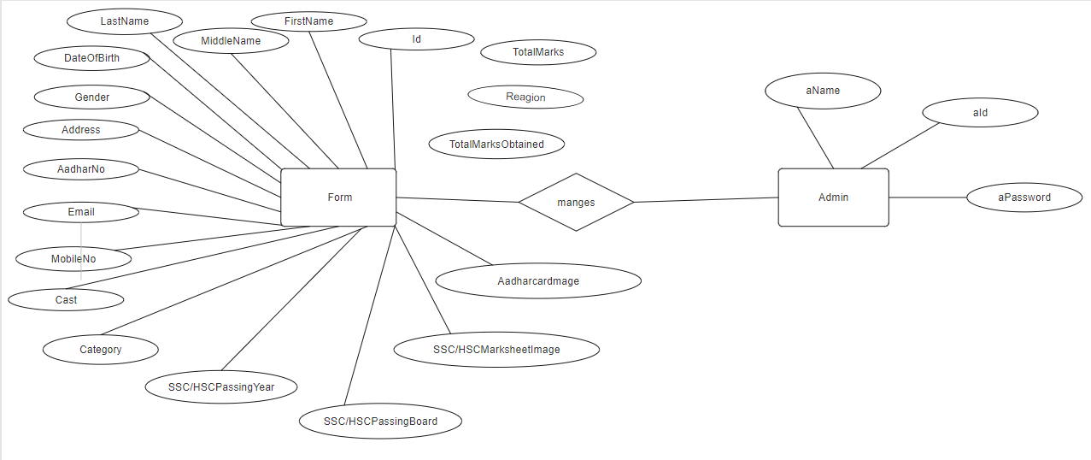

1. **Use-Case Diagram** 
   * Login System

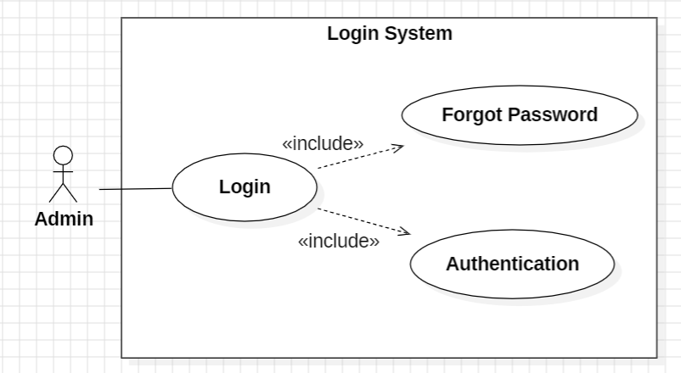

* + Admission Form

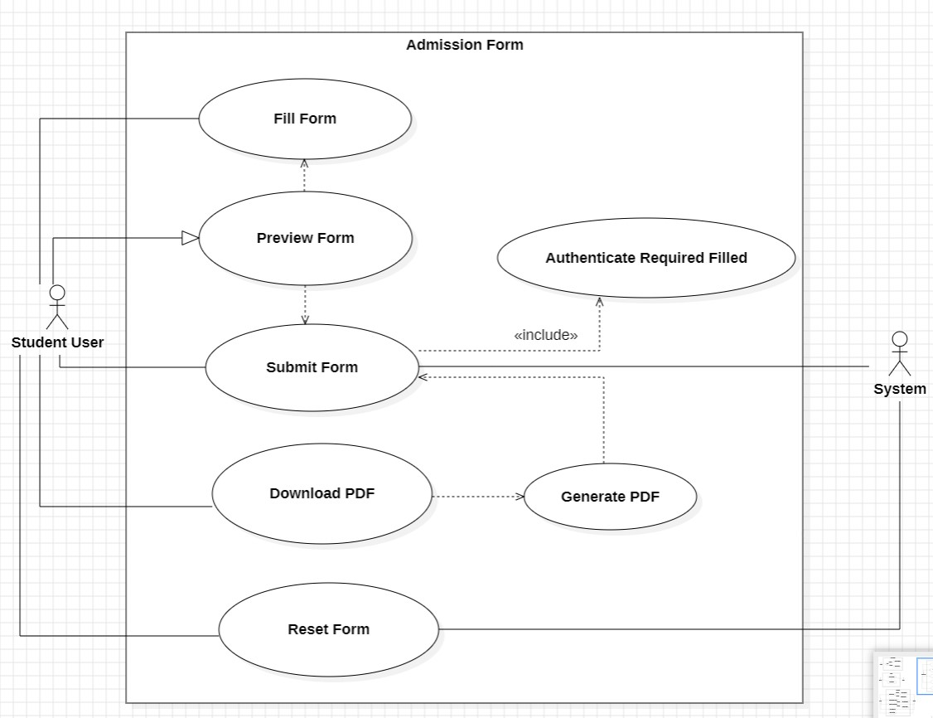

* + Dashboard

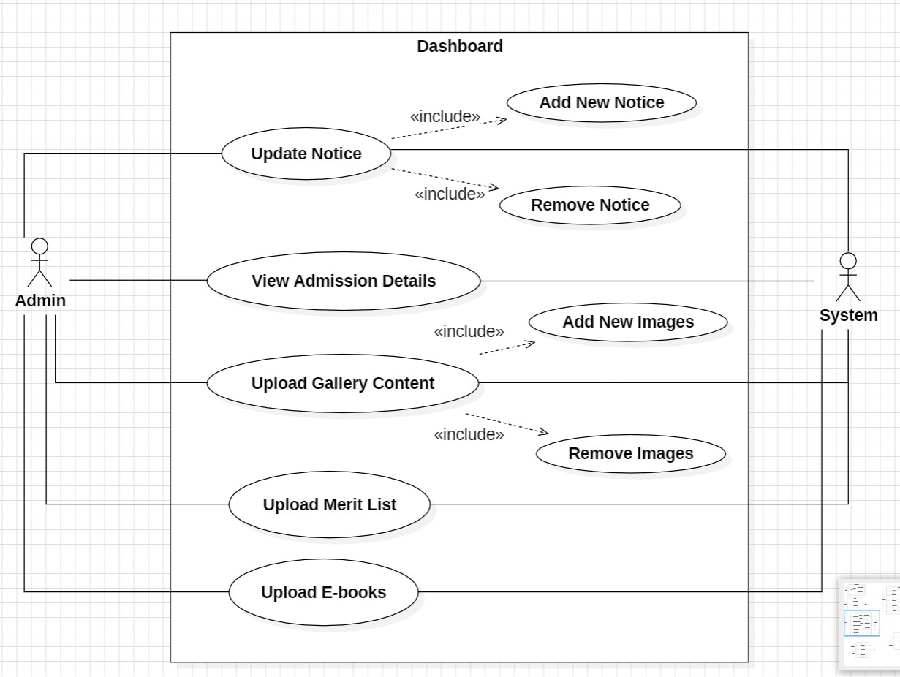

* + Notice

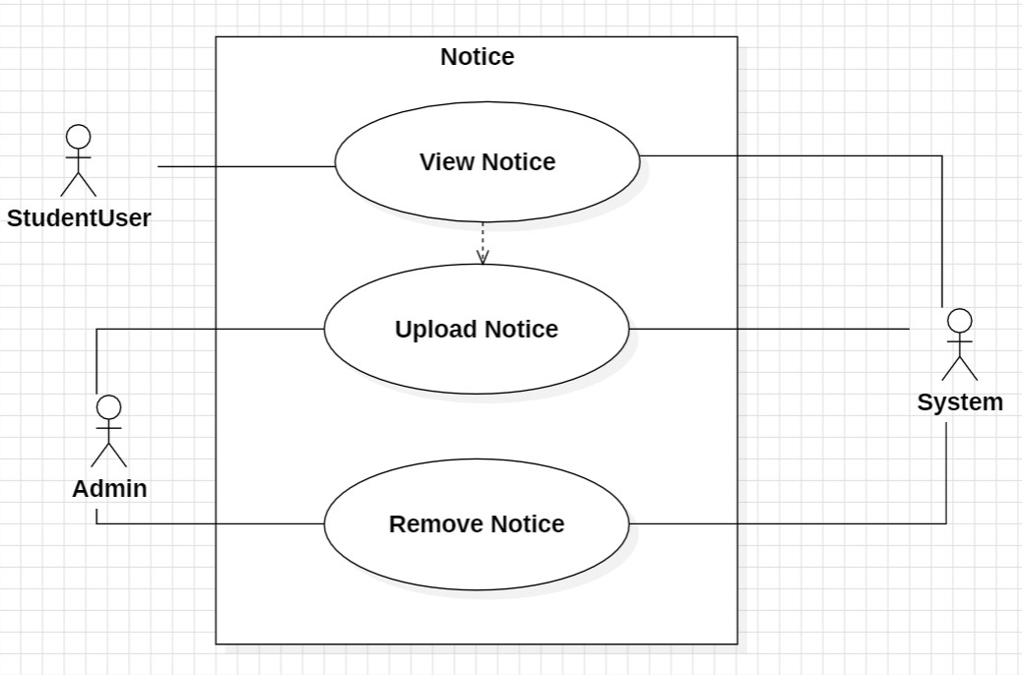

* + Merit List

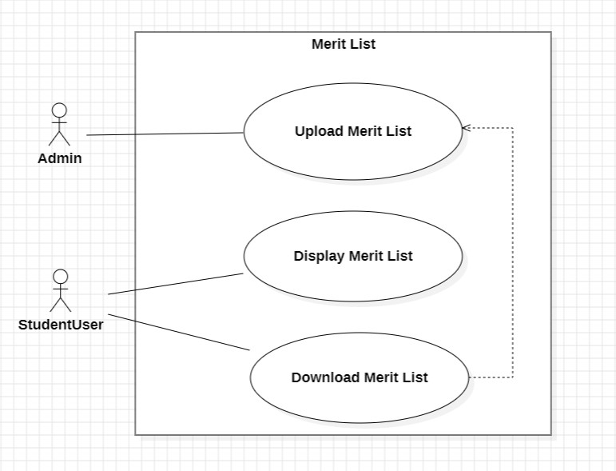

* + E-Books

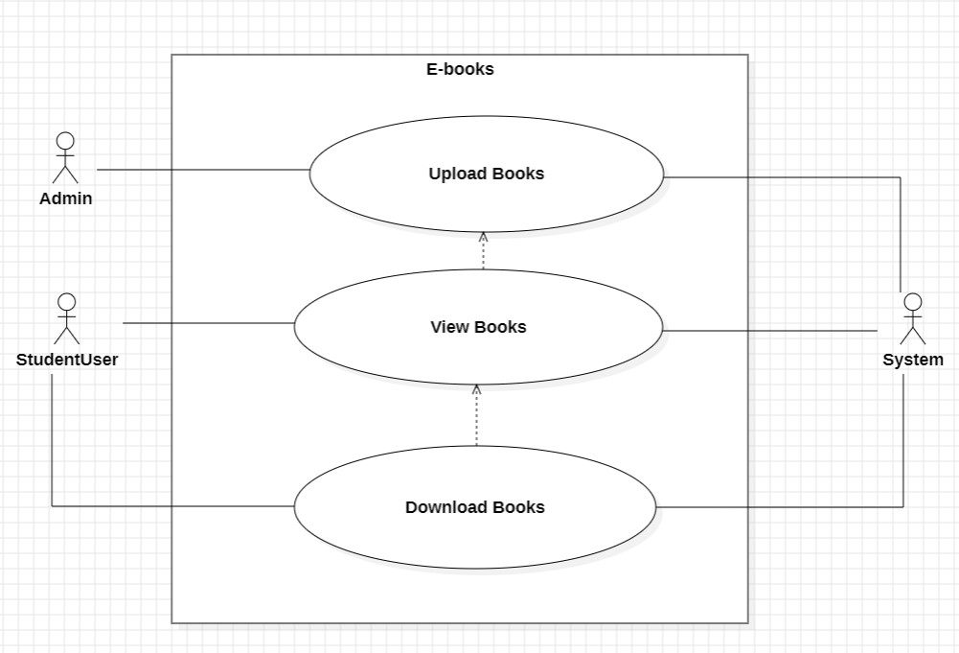

* + Gallery

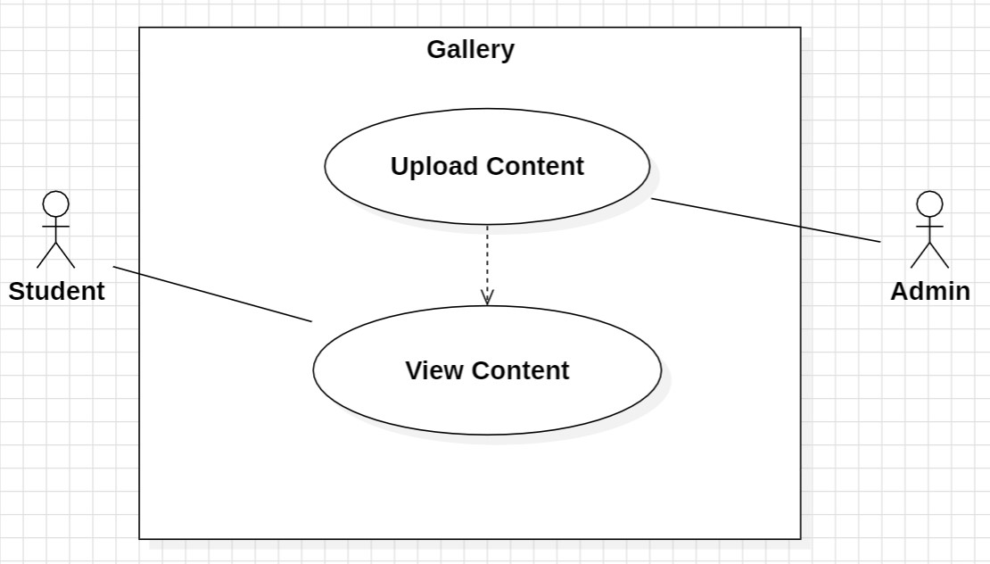

1. **Class Diagram**

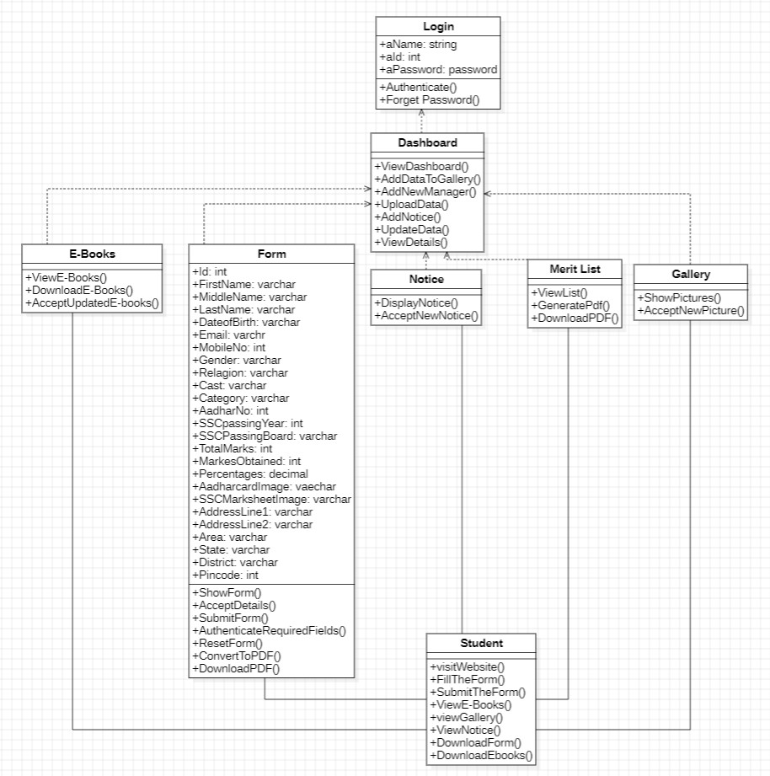

1. **Sequence Diagram** 
   * Database System

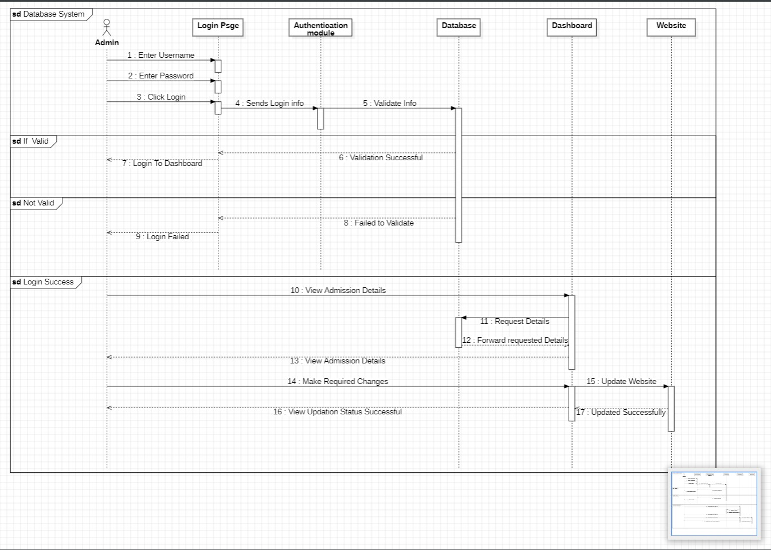

* + Website Page

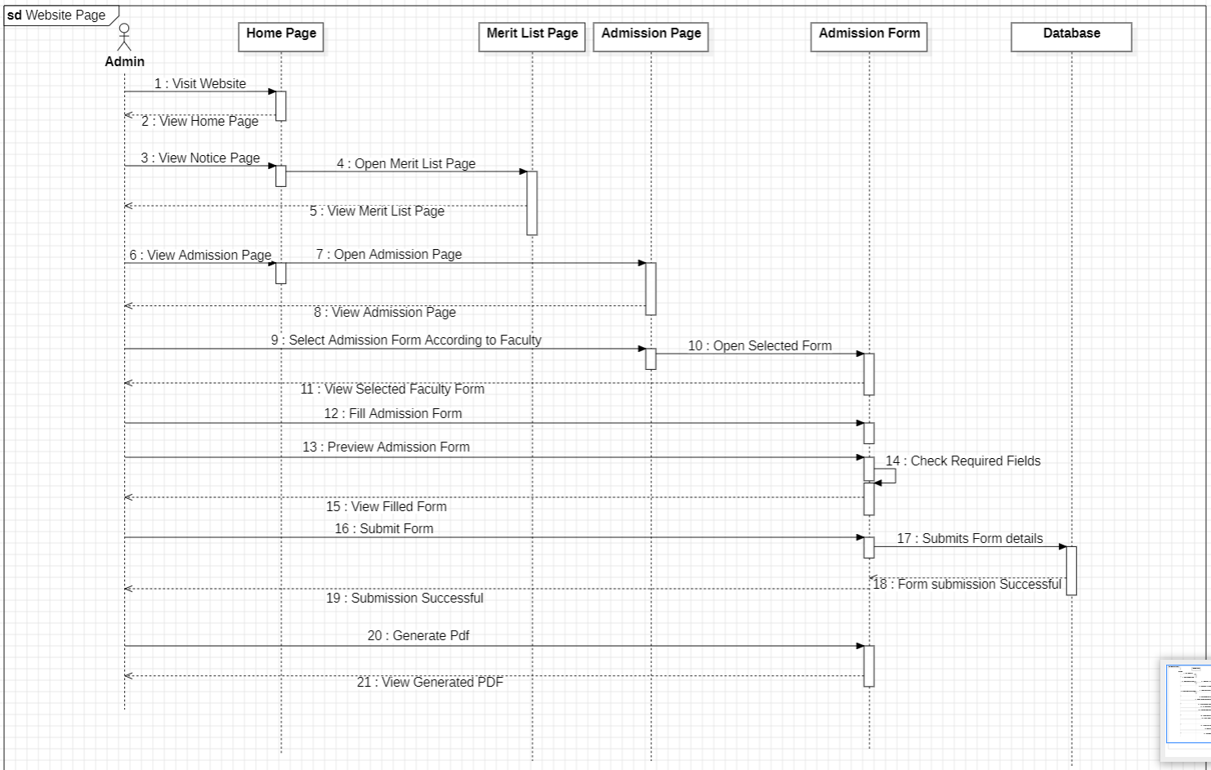

1. **Deployment Diagram**

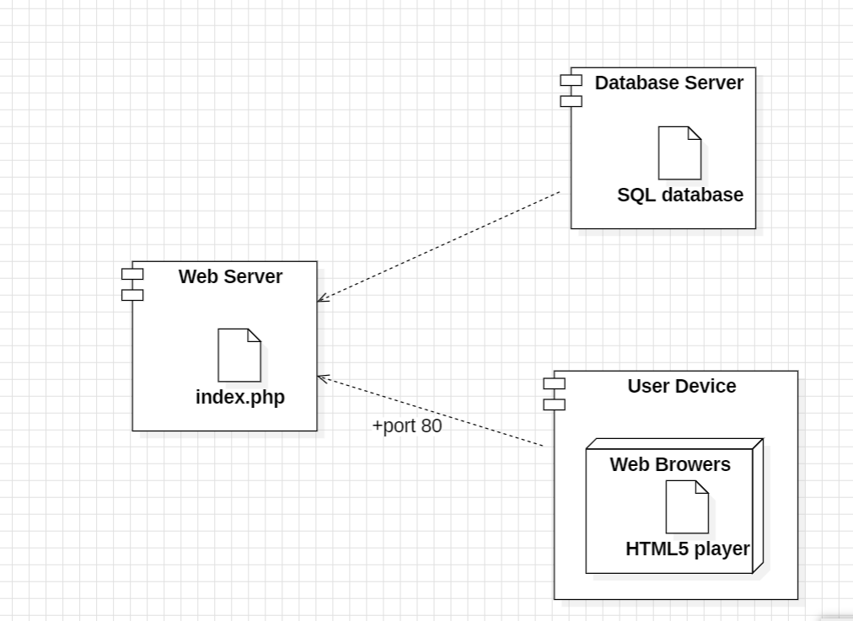

**3.4 Event Table**

|  |  |  |  |  |  |
| --- | --- | --- | --- | --- | --- |
| Event | Trigger | Source | Activity | Output | Destination |
| Login | Admin wants to  Make Changes in  Notice and Merit  list | System | Add new  Photos /  Videos /  Notices | Changes Made | Admin |
| Notice | Wants to know latest Notice and  alerts | System | Latest Notice viewed | Views Notice | Admin and Student User |
| View  Admission Form | Apply a Admission | System | Admission  Process  Details | View  Admission Form | Student User |
| Fill  Admission Form | Confirm Admission | System | Form Filling | Form Filled  Successfully and Generate Roll No. | System and Student User |
| Generate Merit List | See the eligibility | System | Download Pdf  / File | Pdf download or Merit List shown | Student User |
| View EBooks | Reading textbooks online | System | View or download EBooks | E-books  Shown or  Download | Student User |
| Gallery | Insert newly activities | System | Photos and videos  Uploaded by admin | College  Function /  Program  Photos  Displayed | Admin and Student User |

### 4. Implementation and Testing

### 4.1 Connection Code

* **11thCom.php**

<?php

function validateImage($file) {

// Define allowed image types

$allowedTypes = ['image/jpeg', 'image/png'];

// Define maximum file size in bytes (10MB)

$maxFileSize = 10 * 1024 * 1024;

// Check if file type is allowed

if (!in_array($file['type'], $allowedTypes)) {

return "Unsupported image type. Please upload a JPEG or PNG";

}

// Check if file size exceeds the limit

if ($file['size'] > $maxFileSize) {

return "File size exceeds the limit (10MB). Please upload a smaller image.";

}

// Check if the file is an actual image

if (!getimagesize($file['tmp_name'])) {

return "File is not an image.";

}

// No validation errors

return null;

}

$firstName = $_POST['firstName'];

$middleName = $_POST['middleName'];

$lastName = $_POST['lastName'];

$dob = $_POST['dob'];

$email = $_POST['email'];

$mobile = $_POST['mobile'];

$gender = $_POST['gender'];

$religion = $_POST['religion'];

$cast = $_POST['cast'];

$category = $_POST['category'];

$aadhar = $_POST['aadhar'];

$passingyear = $_POST['passingyear'];

$board = $_POST['board'];

$total = $_POST['total'];

$marks = $_POST['marks'];

$percent = $_POST['percent'];

$add1 = $_POST['add1'];

$add2 = $_POST['add2'];

$area = $_POST['area'];

$states = $_POST['states'];

$district = $_POST['district'];

$pincode = $_POST['pincode'];

// Validate and handle image upload for Aadhar

$aadharImageError = validateImage($_FILES['adimg']);

if ($aadharImageError) {

echo $aadharImageError;

exit; // Stop script execution if there's an error

}

$filename = $_FILES['adimg']['name'];

$tempname = $_FILES['adimg']['tmp_name'];

$folder = "11thCom/Aadhar/" . $filename;

move_uploaded_file($tempname, $folder);

// Validate and handle image upload for Marksheet

$markImageError = validateImage($_FILES['markimg']);

if ($markImageError) {

echo $markImageError;

exit; // Stop script execution if there's an error

}

$filename = $_FILES['markimg']['name'];

$tempname = $_FILES['markimg']['tmp_name'];

$folder1 = "11thCom/Marksheet/" . $filename;

move_uploaded_file($tempname, $folder1);

// Database connection

$conn = new mysqli('localhost', 'root', '', 'smbtjunior');

if ($conn->connect_error) {

echo "$conn->connect_error";

die("Connection Failed : " . $conn->connect_error);

} else {

$stmt = $conn->prepare("insert into 11thCom(firstName,middleName,lastName,dob,email,mobile,gender,religion,cast,category,aadhar,passingyear,board,total,marks,percent,adimg,markimg,add1,add2,area,states,district,pincode) values(?, ?, ?, ?, ?, ?, ?, ?, ?, ?, ?, ?, ?, ?, ?, ?, ?, ?, ?, ?, ?, ?, ?,?)");

$stmt->bind_param(

"sssssissssiisiiisssssssi",

$firstName,

$middleName,

$lastName,

$dob,

$email,

$mobile,

$gender,

$religion,

$cast,

$category,

$aadhar,

$passingyear,

$board,

$total,

$marks,

$percent,

$folder,

$folder1,

$add1,

$add2,

$area,

$states,

$district,

$pincode

);

$stmt->execute();

$applicationId = $conn->insert_id;

?>

<!DOCTYPE html>

<html lang="en">

<head>

<meta charset="UTF-8">

<meta name="viewport" content="width=device-width, initial-scale=1.0">

<title>Form Submitted</title>

<link rel="icon" href="../images/hero-img.png">

<style>

@font-face {

font-family: "Raleway-regular";

src: url(../fonts/Raleway-Regular.ttf)

}

@font-face {

font-family: "Raleway-medium";

src: url(../fonts/Raleway-Medium.ttf)

}

@font-face {

font-family: "Raleway-bold";

src: url(../fonts/Raleway-Bold.ttf)

}

@font-face {

font-family: "Raleway-extrabold";

src: url(../fonts/Raleway-ExtraBold.ttf)

}

@font-face {

font-family: "Raleway-semibold";

src: url(../fonts/Raleway-SemiBold.ttf)

}

@font-face {

font-family: "Raleway-black";

src: url(../fonts/Raleway-Black.ttf)

}

* {

margin: 0;

padding: 0;

box-sizing: border-box;

}

body {

height: 100vh;

display: flex;

justify-content: center;

align-items: center;

}

.card {

max-width: 320px;

border-width: 1px;

border-color: rgba(219, 234, 254, 1);

border-radius: 1rem;

background-color: rgba(255, 255, 255, 1);

padding: 1rem;

}

.header {

display: flex;

justify-content: center;

align-items: center;

grid-gap: 1rem;

gap: 1rem;

}

.icon {

flex-shrink: 0;

display: flex;

align-items: center;

justify-content: center;

border-radius: 9999px;

background-color: rgba(96, 165, 250, 1);

padding: 0.5rem;

color: rgba(255, 255, 255, 1);

}

.icon svg {

height: 1rem;

width: 1rem;

}

.alert {

font-family: "Raleway-Bold";

font-weight: 600;

color: rgba(107, 114, 128, 1);

}

.message {

font-family: "Raleway-semibold";

margin-top: 1rem;

color: rgba(107, 114, 128, 1);

}

.actions {

margin-top: 1.5rem;

}

.actions a {

text-decoration: none;

}

.contact-us,

.home {

font-family: "Raleway-semibold";

display: inline-block;

border-radius: 0.5rem;

width: 100%;

padding: 0.75rem 1.25rem;

text-align: center;

font-size: 0.875rem;

line-height: 1.25rem;

font-weight: 600;

}

.home {

font-family: "Raleway-semibold";

background-color: rgba(59, 130, 246, 1);

color: rgba(255, 255, 255, 1);

}

.home:hover {

background-color: rgba(17, 104, 245, 1);

}

.contact-us {

margin-top: 0.5rem;

background-color: rgba(249, 250, 251, 1);

color: rgba(107, 114, 128, 1);

transition: all 0.15s ease;

}

.contact-us:hover {

background-color: rgb(230, 231, 233);

}

</style>

</head>

<body>

<div class="card">

<div class="header">

<span class="icon">

<svg xmlns="http://www.w3.org/2000/svg" viewBox="0 0 20 20" fill="currentColor">

<path fill-rule="evenodd"

d="M18 3a1 1 0 00-1.447-.894L8.763 6H5a3 3 0 000 6h.28l1.771 5.316A1 1 0 008 18h1a1 1 0 001-1v-4.382l6.553 3.276A1 1 0 0018 15V3z"

clip-rule="evenodd"></path>

</svg>

</span>

<p class="alert">Applied Successfully</p>

</div>

<p class="message">

Your Admission application in our college has been successfully submitted. Your Application ID is <?php echo $applicationId; ?>.

</p>

<div class="actions">

<a href="commerce_pdf.php?application_id=<?php echo $applicationId; ?>" id="generatePdfBtn" class="home">Generate PDF </a>

<a href="../index.php" id="homeBtn" class="contact-us" onclick="checkPDF()"> Home </a>

</div>

</div>

<script>

// Disable the home button initially

document.getElementById('homeBtn').style.pointerEvents = 'none';

// Function to check if PDF is generated before allowing home button click

function checkPDF() {

if (document.getElementById('generatePdfBtn').getAttribute('href') === '#') {

alert('Please generate a PDF first.');

} else {

// Allow clicking on the home button if PDF is generated

document.getElementById('homeBtn').href = "../index.php";

}

}

// Enable the home button when the generate PDF button is clicked

document.getElementById('generatePdfBtn').addEventListener('click', function() {

document.getElementById('homeBtn').style.pointerEvents = 'auto';

});

</script>

</body>

</html>

<?php

$stmt->close();

$conn->close();

}

?>

**4.2 Test Case Table**

|  |  |  |  |  |  |  |  |  |
| --- | --- | --- | --- | --- | --- | --- | --- | --- |
| **Requirement** | **Test-**  **Case-**  **Id** | **Test-**  **Condition** | **Test-**  **Data** | **Test-**  **Procedure** | **Expected**  **Outcome** | **Actual**  **Outcome** | **Pass/**  **Fail** | **Rem-arks** |
| Admin login form | TC001 | Valid & available user name& correct password | UserName:sahil@gmail.com  Password:12345 | 1.Fill in all required fields with valid data.  2.submit the form | Login success  Message and Redirect to dashboard | Redirect to dashboard | Pass |  |
|  |  | Valid & available user name& incorrect password | UserName:sahil@gmail.com  Password:123456 | 1.Fill in all required fields with valid data.  2.submit the form | Login Failure Message and Reload login page | Reload login page | Pass |  |
|  |  | Valid & unavailable user name& correct password | UserName:sahil9 @gmail.com  Password:12345 | 1.Fill in all required fields with valid data.  2.submit the form | User Not found Message and Reload login page | Reload login page | Pass |  |
|  |  | invalid user name /password | UserName:admin@gmail.com  Password:adminpa55 | 1.Fill in all required fields with valid data.  2.submit the form | Login failure Message and Reload login Page | Reload login page | Pass |  |
| Registration  Form  submission | TC002 | All required  Fields filled  With valid  data | Full Name:Sahil Shailesh Amberkar BirthDate:28-12-2002,Gender:Male, Address: 1397 Sanjay Niwas Shantinagar,Maharashtra,415639,India ,AadharNo.:123456789012,Email:sahil@gmail.com,MobileNo.:8788948182,etc | 1.Fill in all required fields with valid data.  2.submit the form | Confirmation message:  Registration successful | Registration Successful | Pass |  |
|  |  | Some required fields left blank | Full Name:Sahil Shailesh Amberkar BirthDate:28-12-2002,Gender:Male, Address: 1397 Sanjay Niwas Shantinagar,Maharashtra,415639,India ,AadharNo.:123456789012,Email:sahil@gmail.com,MobileNo.:8788948182,etc | 1.leave some required fields blank.2.Submit the form | Error message:Please fill in all required fields | Please fill in all required fields | Pass |  |
| Validation of Email Format | TC003 | Email format is correct | Email:tejas28@gmail.com | 1.Enter valid Email format.2.Submit the form | Confirmation message:Registration successful | Registration Successful | Pass |  |
|  |  | Email format is incorrect | Email:sahil#gmail.com, | 1.Enter invalid Email format.2.Submit the form | Error message:Please enter a valid email address | Please enter a valid email address | Pass |  |
| Validation of mobile number Format | TC004 | Mobile number format is correct | MobileNo.:8788948182 | 1.Enter valid mobile number format.2.Submit the form | Confirmation message:Registration successful | Registration Successful | Pass |  |
|  |  | Mobile number format is incorrect | MobileNo.:83831 | 1.Enter invalid mobile number format.2.Submit the form | Error message:Please enter a valid mobile number | Please enter a valid mobile number | Pass |  |
| Validation of Aadhar number Format | TC005 | Aadhar number format is correct | AadharNo.:838313399112 | 1.Enter valid Aadhar number format.2.Submit the form | Confirmation message:Registration successful | Registration Successful | Pass |  |
|  |  | Aadhar number format is incorrect | AadharNo.:838313399112123 | 1.Enter invalid Aadhar number format.2.Submit the form | Error message:Please enter a valid Aadhar number | Please enter a valid Aadhar number | Pass |  |
| Validation of marks Format | TC006 | marks Format is correct | Marks:90 | 1.Enter valid marks format.2.Submit the form | Confirmation message:Registration successful | Registration Successful | Pass |  |
|  |  | marks Format is incorrect | Marks:T98 | 1.Enter invalid marks format.2.Submit the form | Error message:Please enter a valid Marks format | Please enter a valid Marks format | Pass |  |

### 5.User Interface Design

**Home Page**

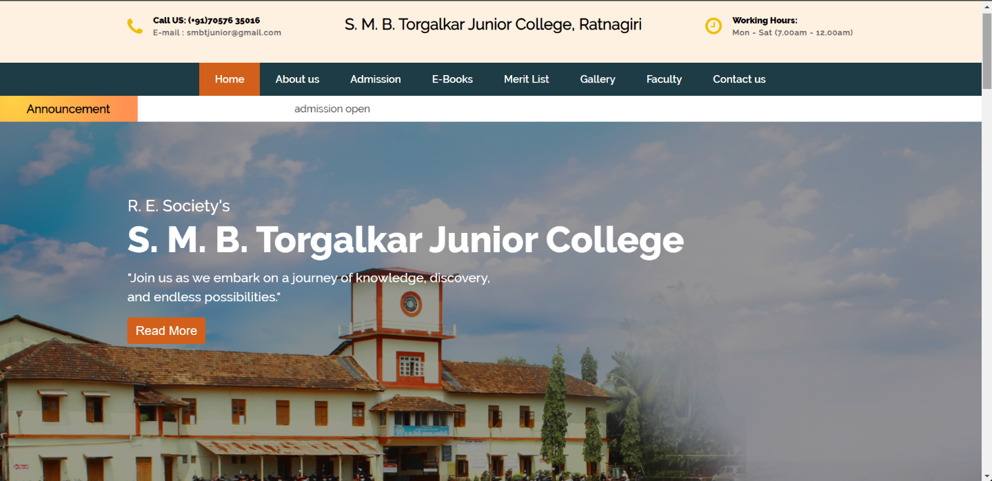

**About Us**

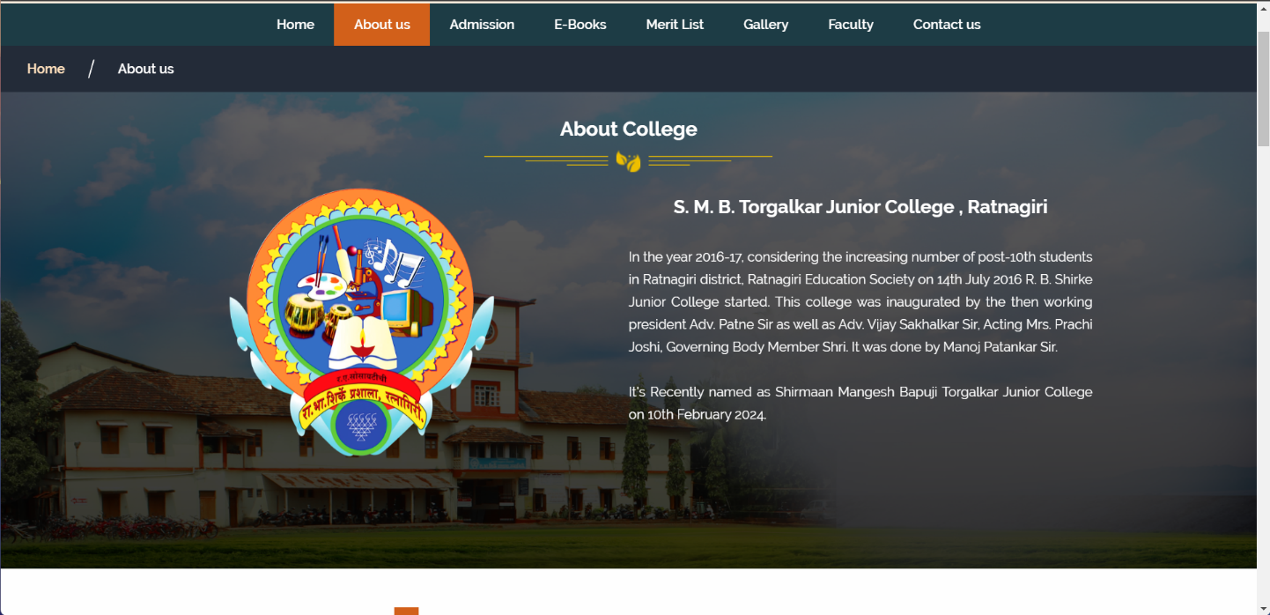

**Admission**

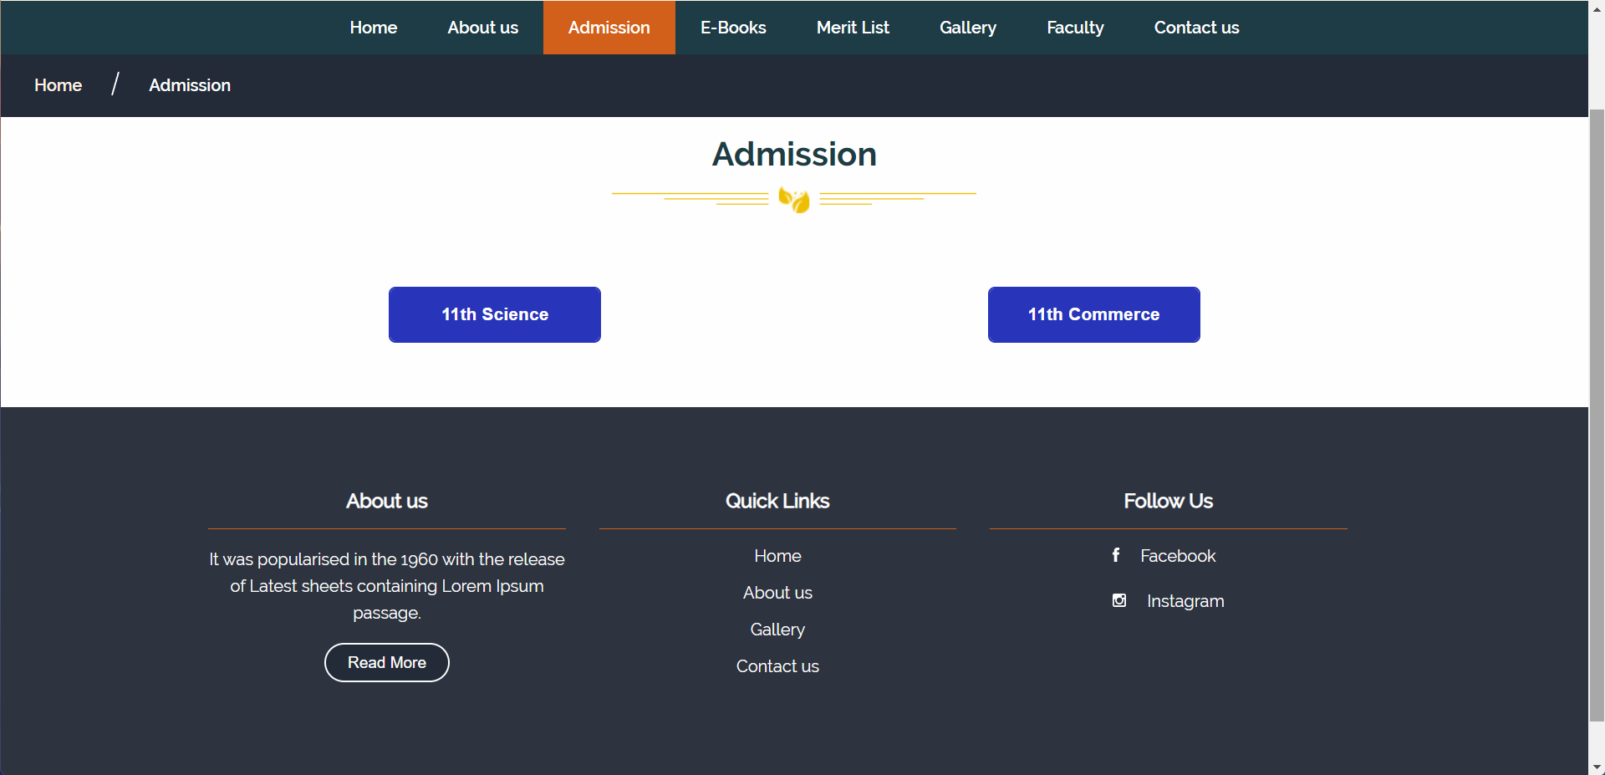

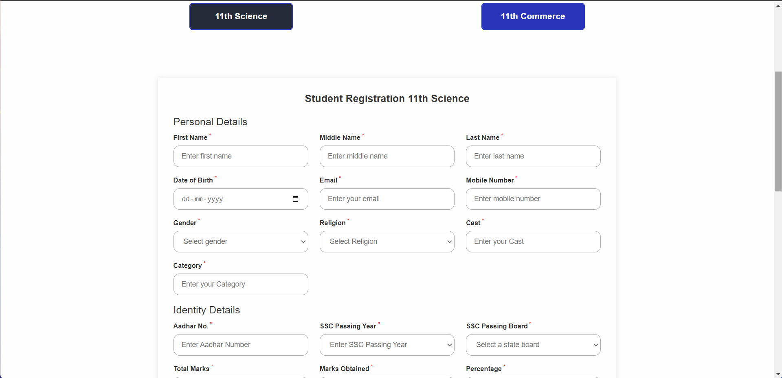

**E-Books**

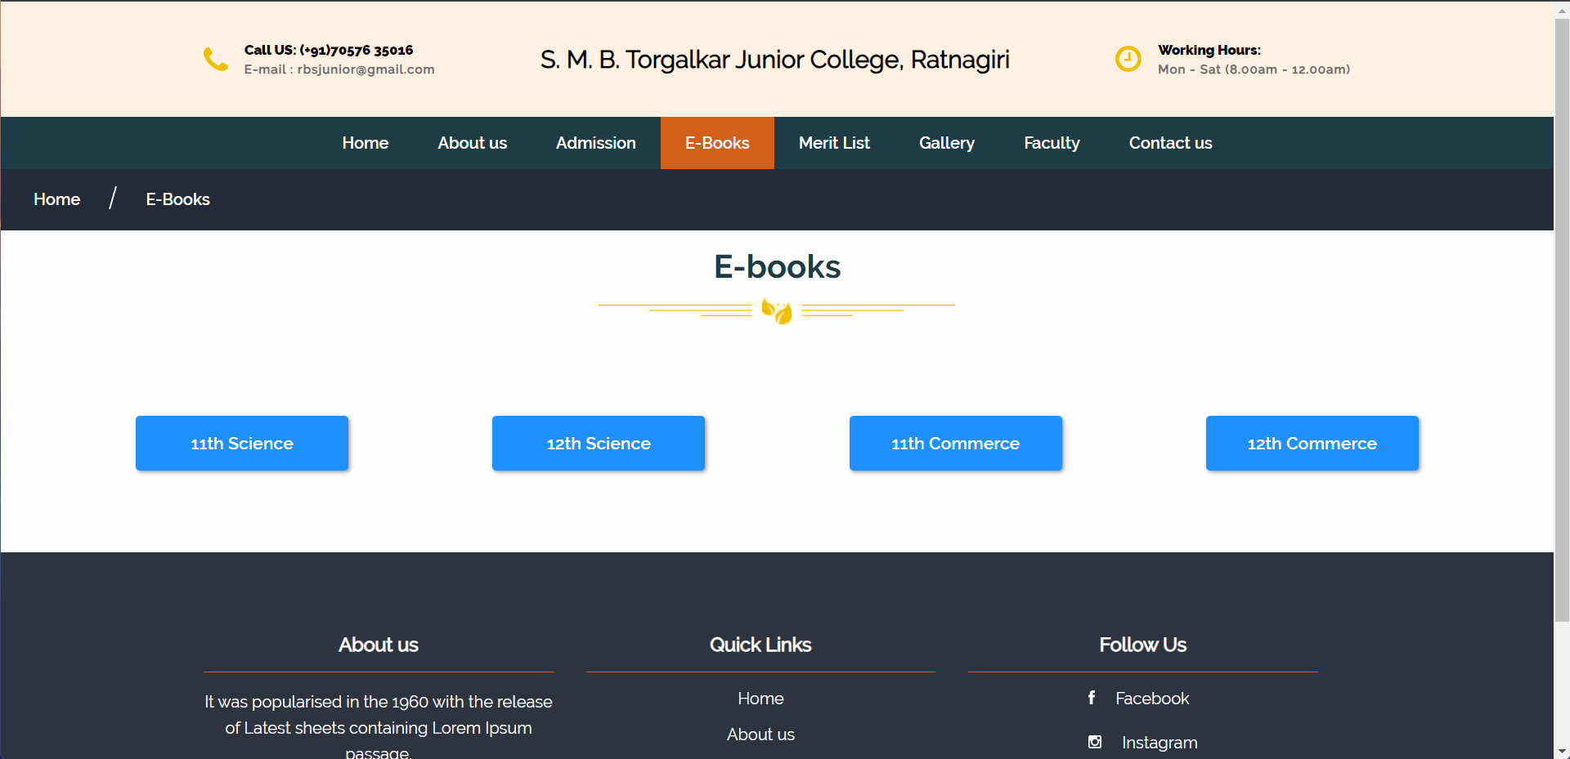

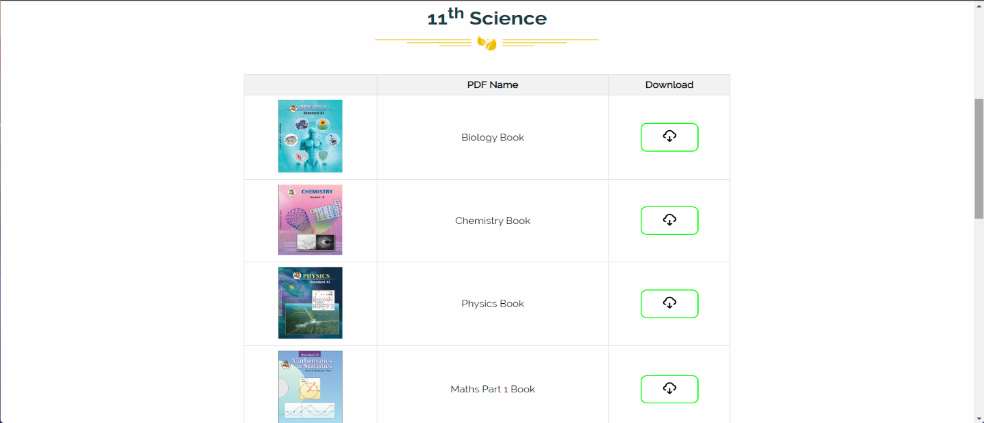

**Merit List**

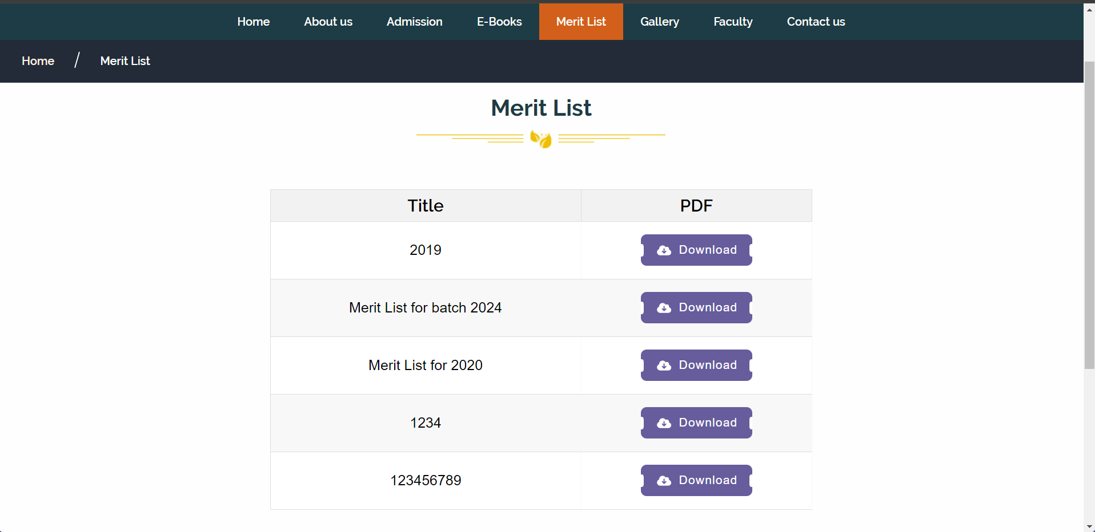

**Gallery**

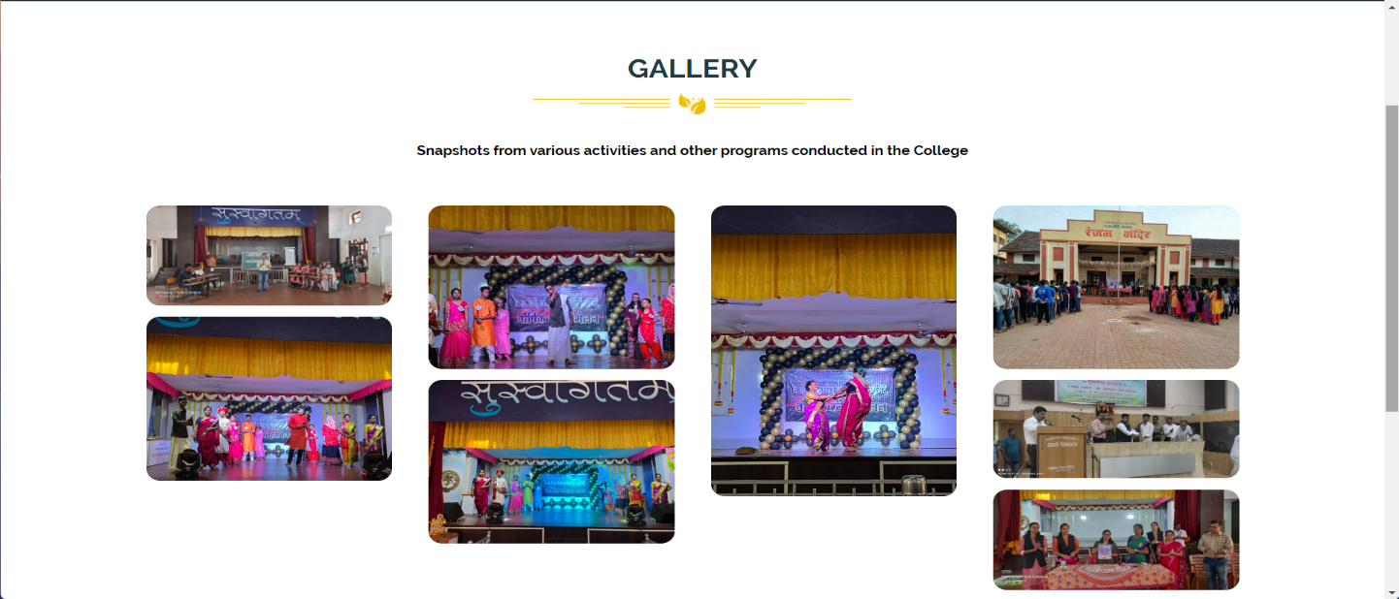

**Faculty**

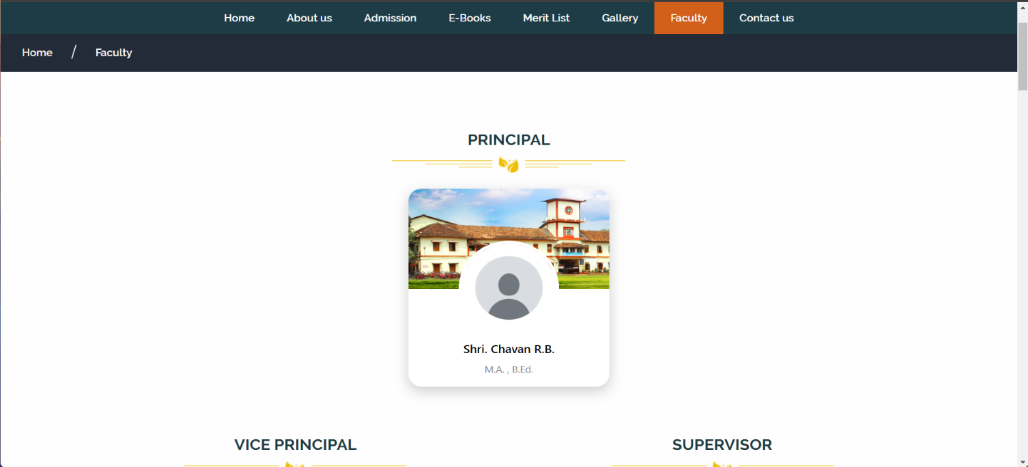

**Contact Us**

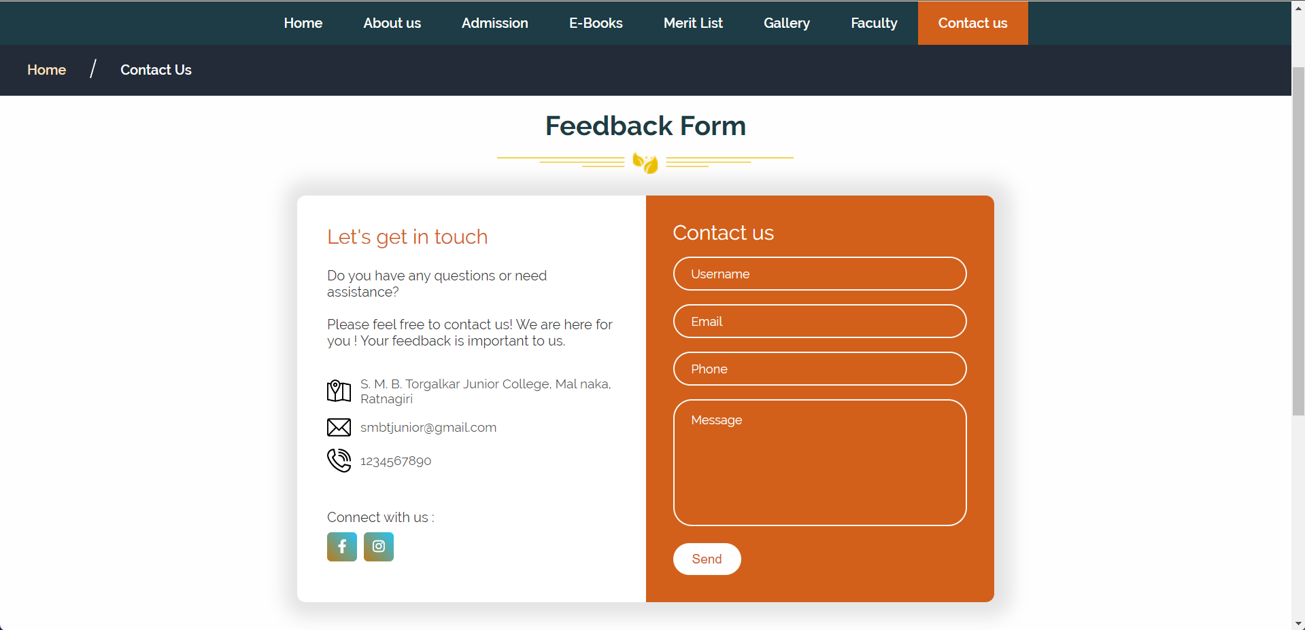

**Admin Login**

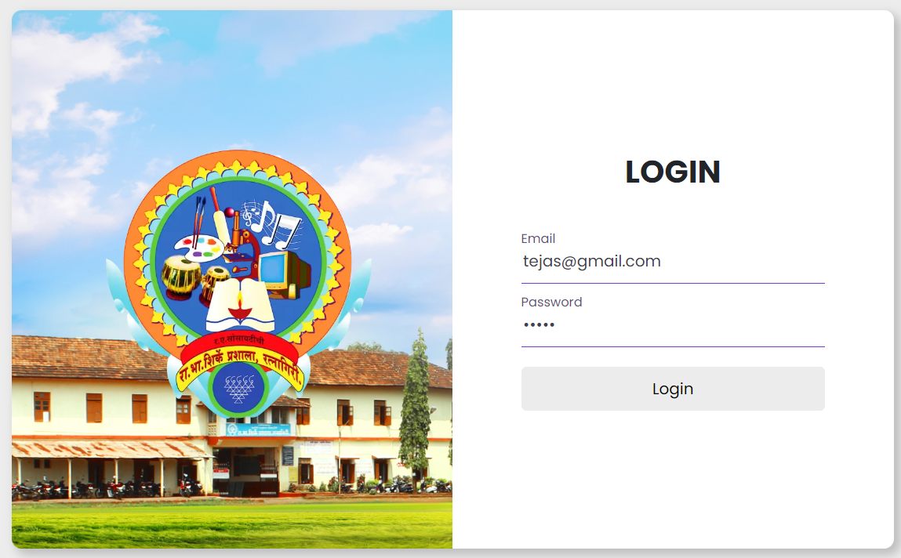

**Dashboard**

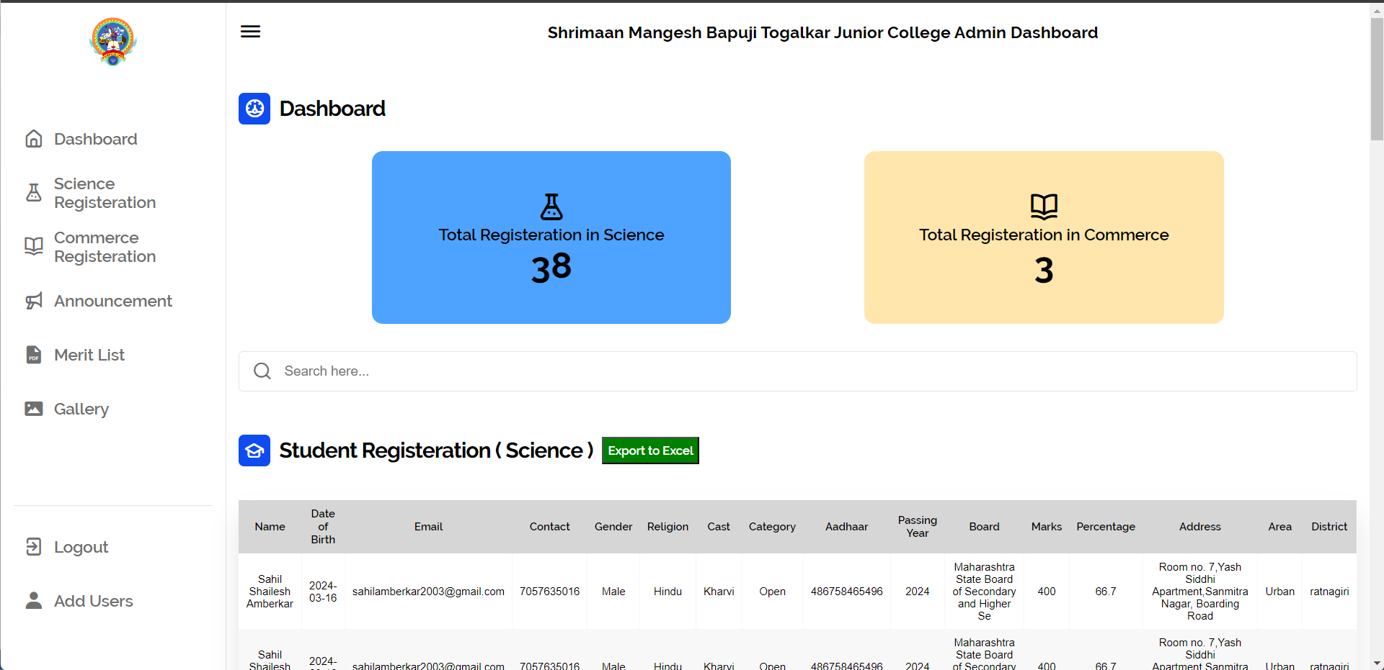

**6. Conclusion**

Embarking on the development journey of the "S. M. B. TORGALKAR Jr. College Website" has been a rewarding experience, allowing me to delve into the intricate world of web development using a variety of technologies including HTML, CSS, JavaScript, Bootstrap, and PHP.

Throughout the project, I have gained invaluable insights into both front-end and back-end web development, as well as the integration of these technologies to create a seamless and functional platform. Each phase of the project presented its own set of challenges, which have not only honed my problem-solving skills but also deepened my understanding of web development principles.

With unwavering dedication, I have strived to ensure that the "S. M. B. TORGALKAR Jr. College Website" not only meets but exceeds the expectations of its users. By implementing user-friendly design elements, responsive layouts, and intuitive navigation, my goal has been to provide an immersive and enjoyable experience for visitors to the website.

I am immensely grateful for the support and guidance provided by our teachers and mentors throughout the duration of this project. Their expertise and encouragement have been instrumental in overcoming obstacles and achieving our objectives.

As we bring this project to a close, my aspiration is that the "S. M. B. TORGALKAR Jr. College Website" serves as a valuable resource for students, faculty, and stakeholders of the college community. I am hopeful that our efforts will not only meet but exceed the expectations of our client, leaving a lasting impact on the college's digital presence.

# 7. References

* [**https://www.rbshirkehighschool.com/**](https://www.rbshirkehighschool.com/)
* [**https://staruml.io/**](https://staruml.io/)
* [**https://gjcrtn.ac.in/**](https://gjcrtn.ac.in/)
* [**https://uiverse.io/**](https://uiverse.io/)
* [**https://boxicons.com/**](https://boxicons.com/)
* **https://iconscout.com/unicons**
* **[https://getbootstrap.com/](C:\\Users\\Manjula Swami\\Downloads\\bootstrap)**